TOPIC:VENDING MACHINE CONTROLLER

1. Introduction:
A vending machine controller is a digital sequential control system that automatically dispenses a product after receiving the required amount of money from the user. It is commonly used in snack, beverage, and ticket vending machines to provide quick and accurate service without manual operation. The controller continuously monitors the inserted coins, calculates the total balance, and performs the required action based on the amount received.

In this project, the vending machine accepts ₹5 and ₹10 coins, while the cost of the product is fixed at ₹15. The controller is designed using a Moore Finite State Machine (FSM), where each state represents the current balance stored in the machine. Depending on the coin inserted, the controller moves from one state to another until the required amount is reached.

The design is implemented in VHDL (VHSIC Hardware Description Language) and simulated using ModelSim. When the balance reaches ₹15, the machine dispenses the product. If the user inserts ₹20 (two ₹10 coins), the controller dispenses the product and returns ₹5 as change. An active-high reset signal returns the controller to the initial state, making it ready for the next transaction.

This project demonstrates the design and analysis of a synchronous sequential logic circuit using FSM concepts and VHDL programming, fulfilling the objectives of the Digital Logic Design laboratory.

2. Objectives

The main objectives of the Vending Machine Controller Using FSM project are:

* To design a vending machine controller using a Finite State Machine (FSM).

* To detect ₹5 and ₹10 coin inputs using digital logic.

* To maintain the total balance by changing states according to the inserted coins.

* To dispense the product automatically when the total amount reaches ₹15.

* To return ₹5 as change when the inserted amount exceeds the product price (₹20 total).

* To implement the vending machine controller in VHDL using synchronous sequential logic.

* To verify the functionality of the design using a VHDL testbench and ModelSim simulation.

3.BLOCK DIAGRAM

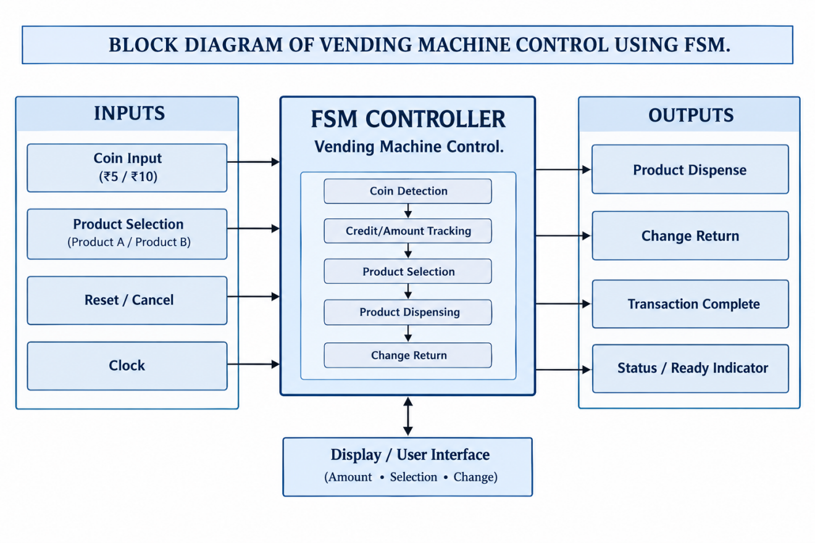

- FSM STATE DIAGRAM:

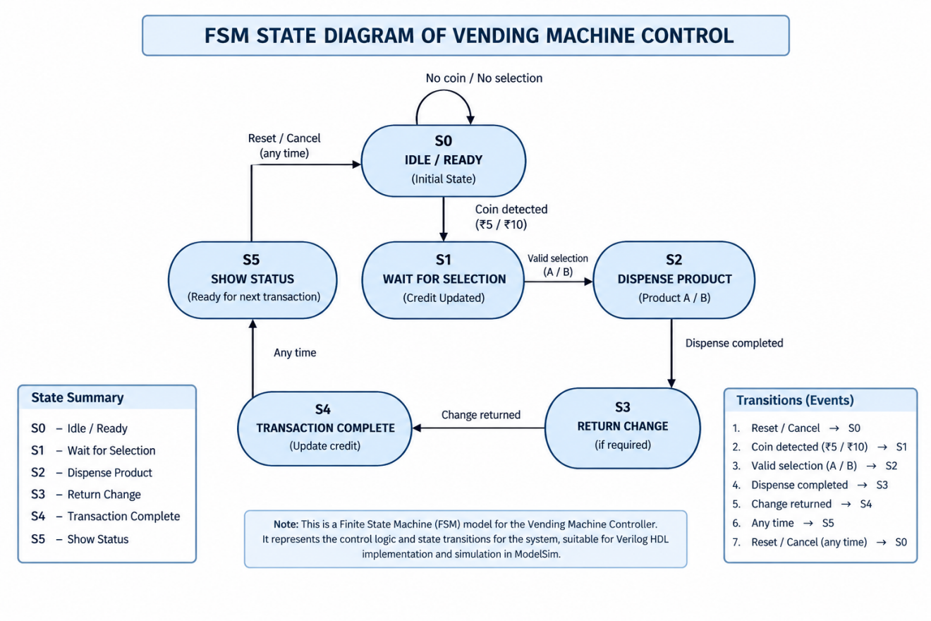

- STATE TABLE
Present State | Input / Condition | Next State | Output / Action
S0 – IDLE | ₹5 / ₹10 coin | S1 | Update credit
S1 – SELECTION | Product A selected + sufficient credit | S2 | Dispense A
S1 – SELECTION | Product B selected + sufficient credit | S3 | Dispense B
S1 – SELECTION | Insufficient credit | S1 | Wait for more coins
S1 – SELECTION | Cancel | S0 | Refund amount
S2 – DISPENSE A | Dispensing complete | S4 | Check change
S3 – DISPENSE B | Dispensing complete | S4 | Check change
S4 – CHANGE | Change required | S5 | Return change
S4 – CHANGE | No change | S5 | No change
S5 – COMPLETE | Transaction complete | S0 | Ready for next customer

- STATE ASSIGNMENT
State assignment means giving a binary code to each FSM state so that it can be represented inside digital hardware.
For your vending machine, we have 6 states, so we need 3 bits because:
2^3 = 8
A simple state assignment is:
State | State Name | Binary Assignment
S0 | IDLE | 000
S1 | WAIT SELECTION | 001
S2 | DISPENSE PRODUCT A | 010
S3 | DISPENSE PRODUCT B | 011
S4 | RETURN CHANGE | 100
S5 | TRANSACTION COMPLETE | 101
The remaining codes 110 and 111 are unused.
- STATE TRANSITIONS
State transition is the process by which a Finite State Machine (FSM) moves from its current state to another state based on a specific input or condition.
In the vending machine controller, the state transition occurs according to the input received, such as coin insertion, product selection, cancellation, or completion of dispensing.
The main state transition sequence is:
S0 → S1 → S2/S3 → S4 → S5 → S0
where S0 represents Idle, S1 represents Wait for Selection, S2/S3 represent Dispensing Product A/B, S4 represents Return Change, and S5 represents Transaction Complete.
.
- OUTPUT LOGIC
The output logic determines the actions performed by the vending machine according to the current FSM state and input conditions.
State | Output / Action
S0 – IDLE | Ready indicator ON
S1 – WAIT SELECTION | Credit updated; wait for product selection
S2 – DISPENSE PRODUCT A | Product A dispensing signal ON
S3 – DISPENSE PRODUCT B | Product B dispensing signal ON
S4 – RETURN CHANGE | Change return signal ON
S5 – TRANSACTION COMPLETE | Transaction complete signal ON
Thus, the output logic ensures that the appropriate action is generated for each state of the vending machine.
- VHDL CODE

library IEEE;
use IEEE.STD_LOGIC_1164.ALL;

entity vending_machine is
Port (
clk : in STD_LOGIC;
reset : in STD_LOGIC;
coin : in STD_LOGIC_VECTOR(1 downto 0);
select_product : in STD_LOGIC;
dispense : out STD_LOGIC;
change : out STD_LOGIC
);
end vending_machine;

architecture Behavioral of vending_machine is

-- Completely clean state names to avoid any possible conflict
type state_type is (ST_IDLE, ST_COIN_1, ST_COIN_2, ST_DISPENSE, ST_CHANGE);
signal current_state : state_type;
signal next_state : state_type;

begin

-- Process 1: Clocked State Register
process(clk, reset)
begin
if reset = '1' then
current_state <= ST_IDLE;
elsif rising_edge(clk) then
current_state <= next_state;
end if;
end process;

-- Process 2: Combinational Next State Logic
process(current_state, coin, select_product)
begin
-- Safe default state hold
next_state <= current_state;

case current_state is
when ST_IDLE =>
if coin = "01" then
next_state <= ST_COIN_1;
elsif coin = "10" then
next_state <= ST_COIN_2;
else
next_state <= ST_IDLE;
end if;

when ST_COIN_1 =>
if coin = "01" then
next_state <= ST_COIN_2;
elsif coin = "10" then
next_state <= ST_DISPENSE;
else
next_state <= ST_COIN_1;
end if;

when ST_COIN_2 =>
if select_product = '1' then
next_state <= ST_DISPENSE;
else
next_state <= ST_COIN_2;
end if;

when ST_DISPENSE =>
next_state <= ST_CHANGE;

when ST_CHANGE =>
next_state <= ST_IDLE;

when others =>
next_state <= ST_IDLE;
end case;
end process;

-- Process 3: Concurrent Safe Output Assignments
dispense <= '1' when (current_state = ST_DISPENSE) else '0';
change <= '1' when (current_state = ST_CHANGE) else '0';

end Behavioral;
- TESTBENCH

library IEEE;
use IEEE.STD_LOGIC_1164.ALL;

entity tb_vending_machine is
end tb_vending_machine;

architecture behavior of tb_vending_machine is

-- Inputs to the vending machine
signal clk : STD_LOGIC := '0';
signal reset : STD_LOGIC := '0';
signal coin : STD_LOGIC_VECTOR(1 downto 0) := "00";
signal select_product : STD_LOGIC := '0';

-- Outputs from the vending machine
signal dispense : STD_LOGIC;
signal change : STD_LOGIC;

constant clk_period : time := 10 ns;

begin

-- Instantiate the vending machine
uut: entity work.vending_machine
port map (
clk => clk,
reset => reset,
coin => coin,
select_product => select_product,
dispense => dispense,
change => change
);

-- Clock generation
clk_process : process
begin
while true loop
clk <= '0';
wait for clk_period / 2;
clk <= '1';
wait for clk_period / 2;
end loop;
end process;

-- Test sequence
stimulus_process : process
begin

-- Reset
reset <= '1';
wait for 20 ns;
reset <= '0';
wait for 10 ns;

-- Insert first coin
coin <= "01";
wait for 10 ns;
coin <= "00";
wait for 10 ns;

-- Insert second coin
coin <= "01";
wait for 10 ns;
coin <= "00";
wait for 10 ns;

-- Select product
select_product <= '1';
wait for 10 ns;
select_product <= '0';
wait for 30 ns;

-- Test another transaction
coin <= "01";
wait for 10 ns;
coin <= "00";
wait for 10 ns;

coin <= "01";
wait for 10 ns;
coin <= "00";
wait for 10 ns;

select_product <= '1';
wait for 10 ns;
select_product <= '0';
wait for 30 ns;

-- End simulation
wait;

end process;

end behavior;

- OUTPUT OF VHDL CODE

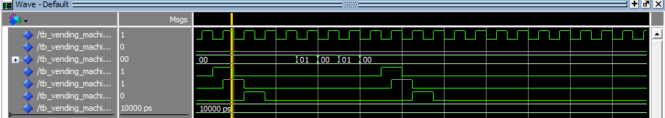

- SIMULATION RESULT

Simulation Step | Input Condition |  |  | Observed Output / FSM Action
1. Reset State | reset = 1, coin = 00, select = 0 |  |  | FSM enters IDLE state. dispense = 0, change = 0.
2. First Coin Inserted | coin = 01 (₹5 coin) |  |  | Machine detects ₹5 and updates balance to ₹5. No product dispensed.
3. Second Coin Inserted | coin = 01 (another ₹5 coin) |  |  | Total balance becomes ₹10. FSM waits for product selection.
4. Product Selection | select = 1 |  |  | FSM checks the available balance against product price.
5. Product Dispensed | Balance ≥ Product Price |  |  | dispense = 1 for one clock cycle. Product is released.
6. Return to Idle | select = 0, coin = 00 |  |  | dispense = 0, change = 0. FSM returns to IDLE state for the next transaction.

- CONCLUSION:
The Vending Machine Controller was successfully designed and implemented using a Finite State Machine (FSM) in VHDL. The controller accurately performs the required operations, including coin detection, balance calculation, product selection, product dispensing, and returning to the idle state after completing a transaction.
The design was simulated in ModelSim, and the waveform results verified the correct state transitions and output responses for different input conditions. This project demonstrates the practical application of synchronous sequential logic and FSM design using VHDL for digital system implementation.
Overall, the project achieved its objective of designing a reliable and efficient vending machine controller, while providing a clear understanding of FSM modeling, VHDL programming, and hardware simulation techniques used in digital electronics.

